**Lecture #2 Notes**

You need to code in an environment

You will use unix

Function main arguments

Void main() – doesn’t return anything

Void main(void) – doesn’t return anything, or take parameters

[type] “function ([args])

Parameters it needs to work

Returns

Name of function

**Identifiers**

**Available: A ..Z,a…z, 0…9**

**Dont use underscore, or else u rewrite seminal system variables**

**Strt w/ letter or underscore**

**Basic Data Types: Integers**

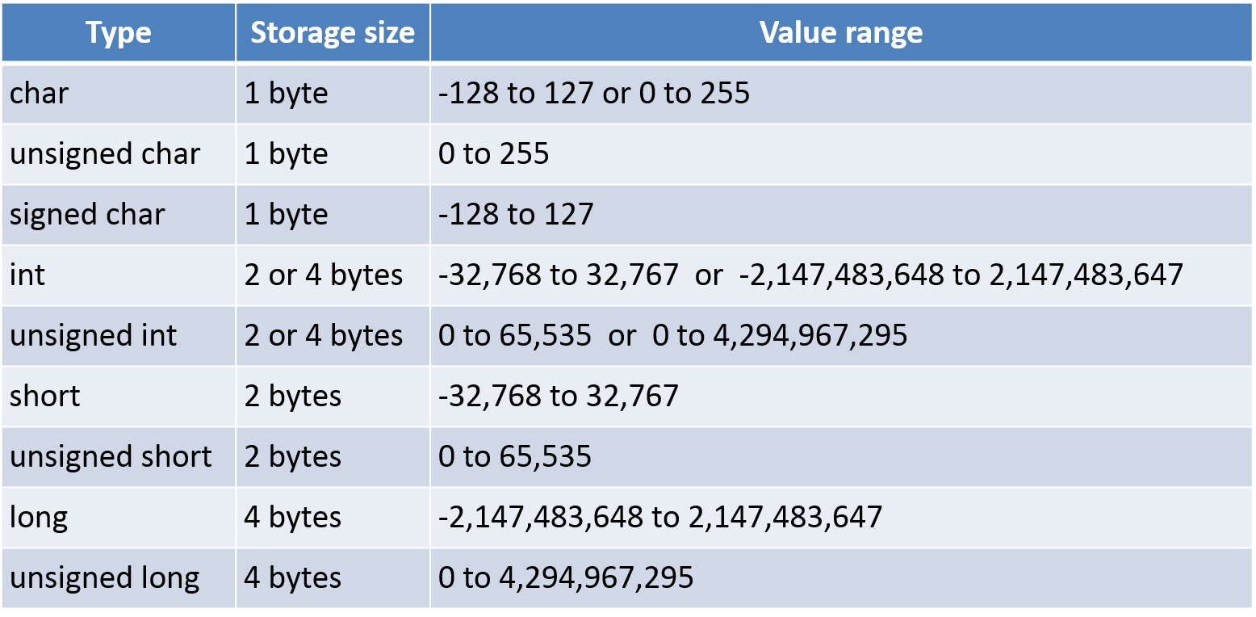

**Basic Data Types: Floating-Point**

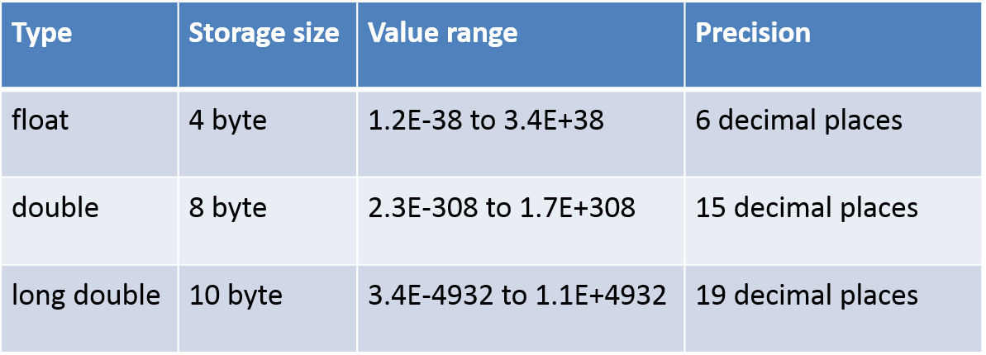

**Variables**

**Need be defined**

**Declared : int integer1,integer2**

Initialized : **integer = 1**

**POINTERS**

**\*var = initializing pointer**

**&var = getting result of pointer**

**No * return address, an int hexademical**

**\*** **returns value of variable**

**Pointer gunna be same size of type its pointing to**

INT. CONSTANTS

ANY INTEGER # IS A CONST

NAME -ONLY CAPS ARE ALLOWED, CAN USE UNDERSCORE IN MIDDLE NOT BEGIN..

CONSTANT WITH NO NAME

CAN BEGIN WITH 0 0X(HEX-numbers) OR NONE

Ex: 0XDC13 is DC1316

FLOATING POINT CONSTANTS

CAN BE USED IN DECIMAL OR EXPONENTIAL FORM

CHARACTER A~~ND STRING CONSTANTS~~

~~CHARACTER CONTSTANTS PLACED IN SINGLE QUOTES~~

~~STRING CONSTANT PLACED IN DOUBLE QUOTES~~

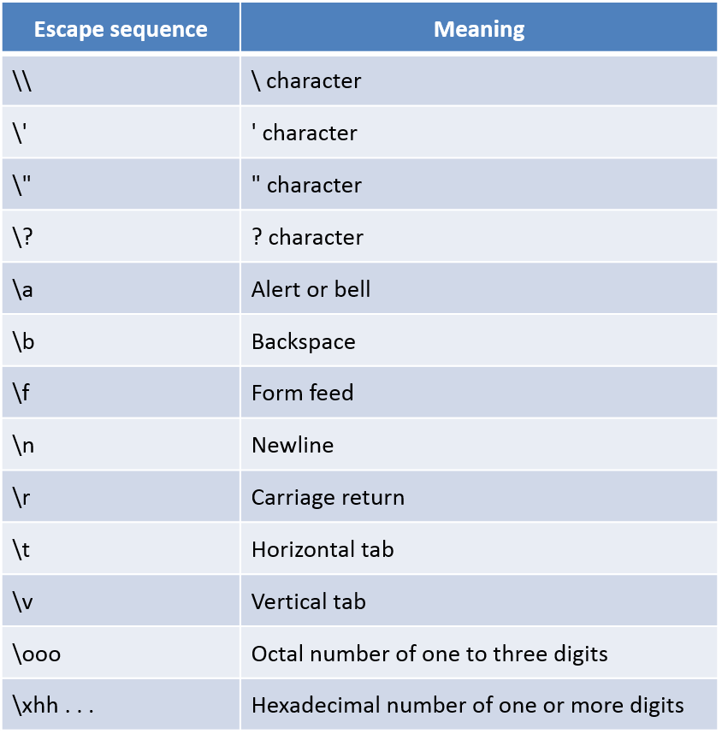

**Defining Constants**

**#Define – makes things global**

**Formatting Number**

**“%(num)d” – decimal with four digits**

**GET**

**Logic Operators**

**Any value different from zero is considered true**

***BitWise Operators***

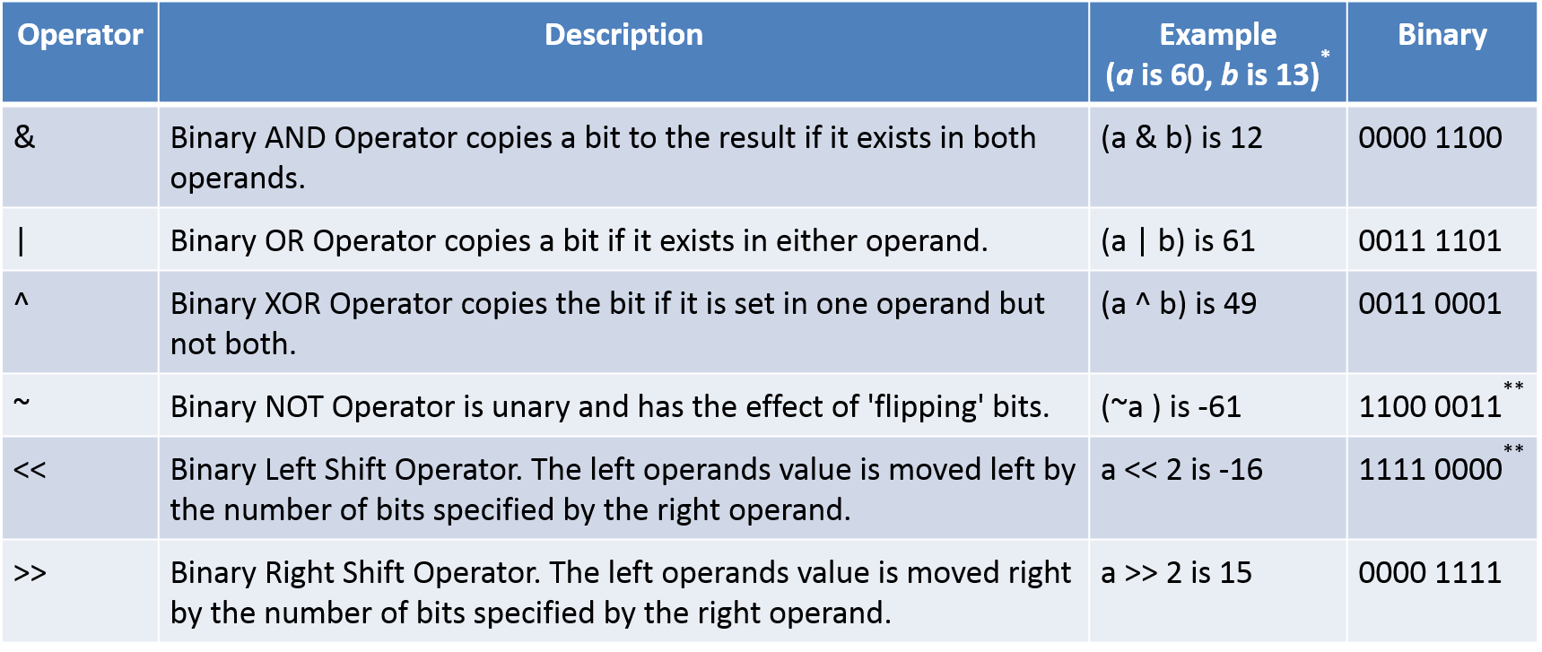***One as first bit in binary num ber for ints tells us its negative***